Build a Natural Language Slack Bot for your Dev Team

Before getting started, please open 5 browser tabs. Log in to each of these sites:

* <https://dev.botframework.com>
* <https://portal.azure.com>
* https://{yourname}.visualstudio.com
* <https://www.luis.ai>
* https://{yourname}.slack.com

Most of these services use your Microsoft ID. It works best if you have the same ID for all of them.

Slack, however, does not use the Microsoft ID. Log into your personal Slack account as you will. Please note that you need to be an administrator of that account!

# Create a Bot using the Azure Bot Service

Go to <https://dev.botframework.com/> and click “Create a Bot or Skill”. Log in with your Microsoft ID, preferably the same one as your VSTS and Azure accounts.

Use “Create a bot with the Azure Bot Service”.  
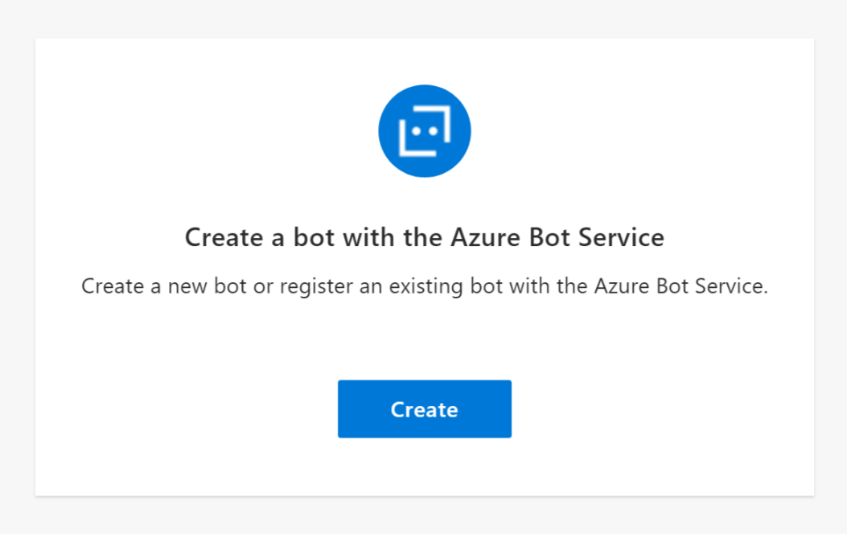

The Azure portal will open up. If you aren’t logged in, log in now. Select “Web App Bot”, and click “Create”.

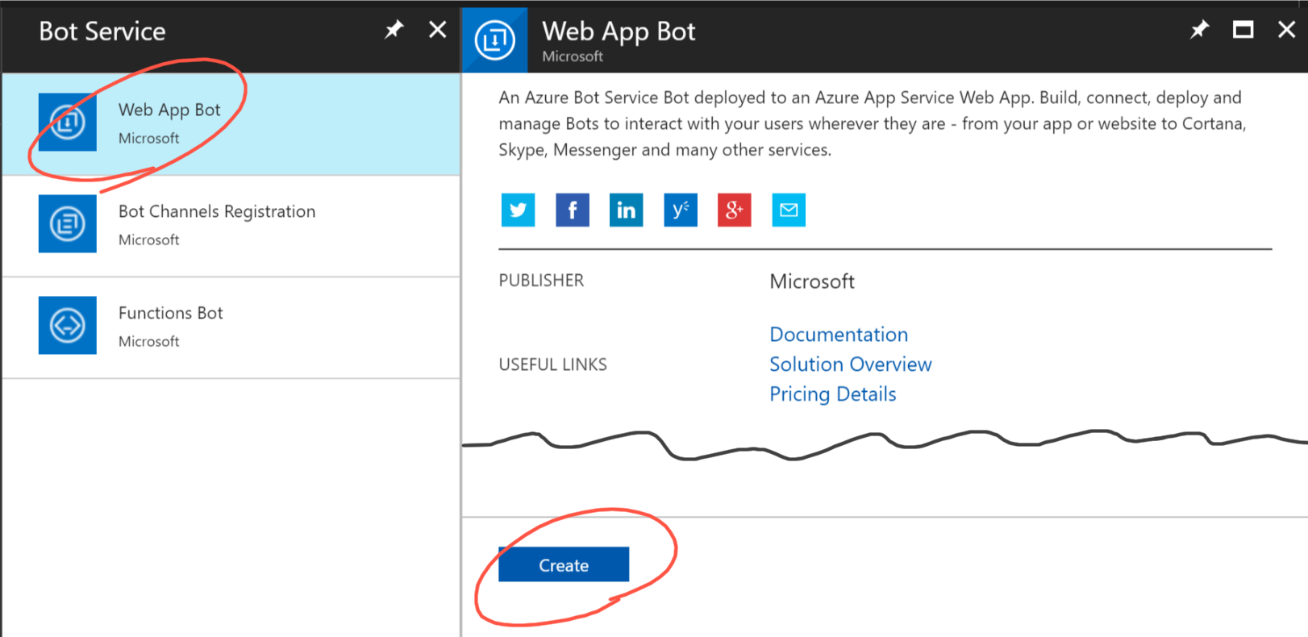

Create a new Bot Service named “devopsbots-<yourname>” using App Service Plan hosting and pin it to your dashboard. **IMPORTANT: Choose the “West US” region.**  
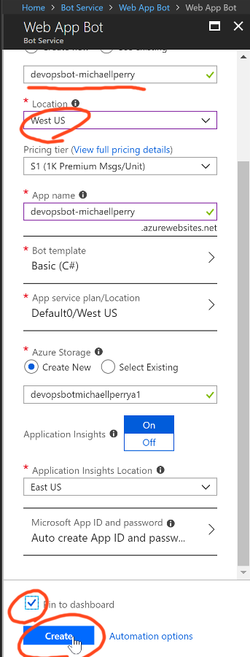

Azure is creating your bot and deploying it to your selected service plan. In the meantime, let’s go to VSTS and create a new home for your project.

# Create a VSTS project for the bot source code

Navigate to your visualstudio.com account (mine is https://michaellperry.visualstudio.com, but yours is not). Click “New Project”.  
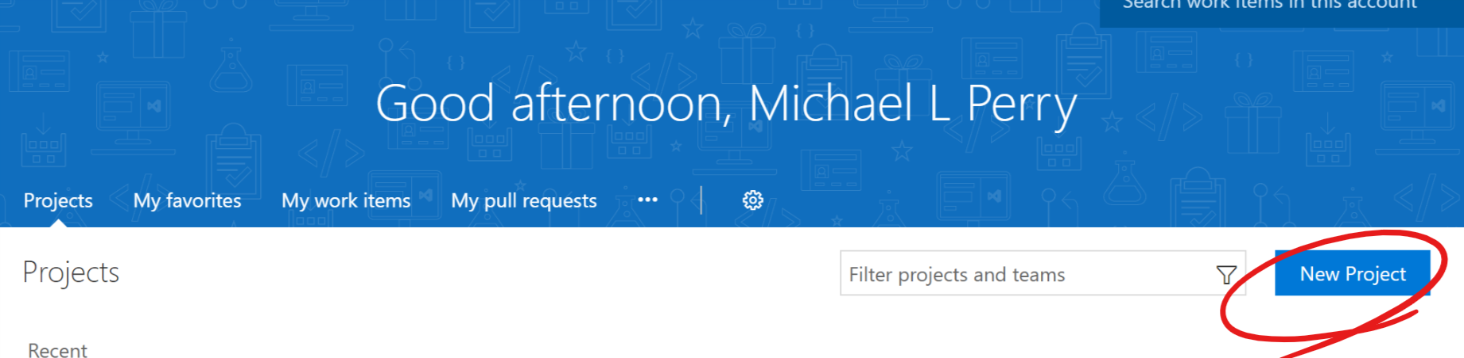

Create your new project. Call it “devopsbot-<yourname>”, keep Git selected for version control, and click “Create”.  
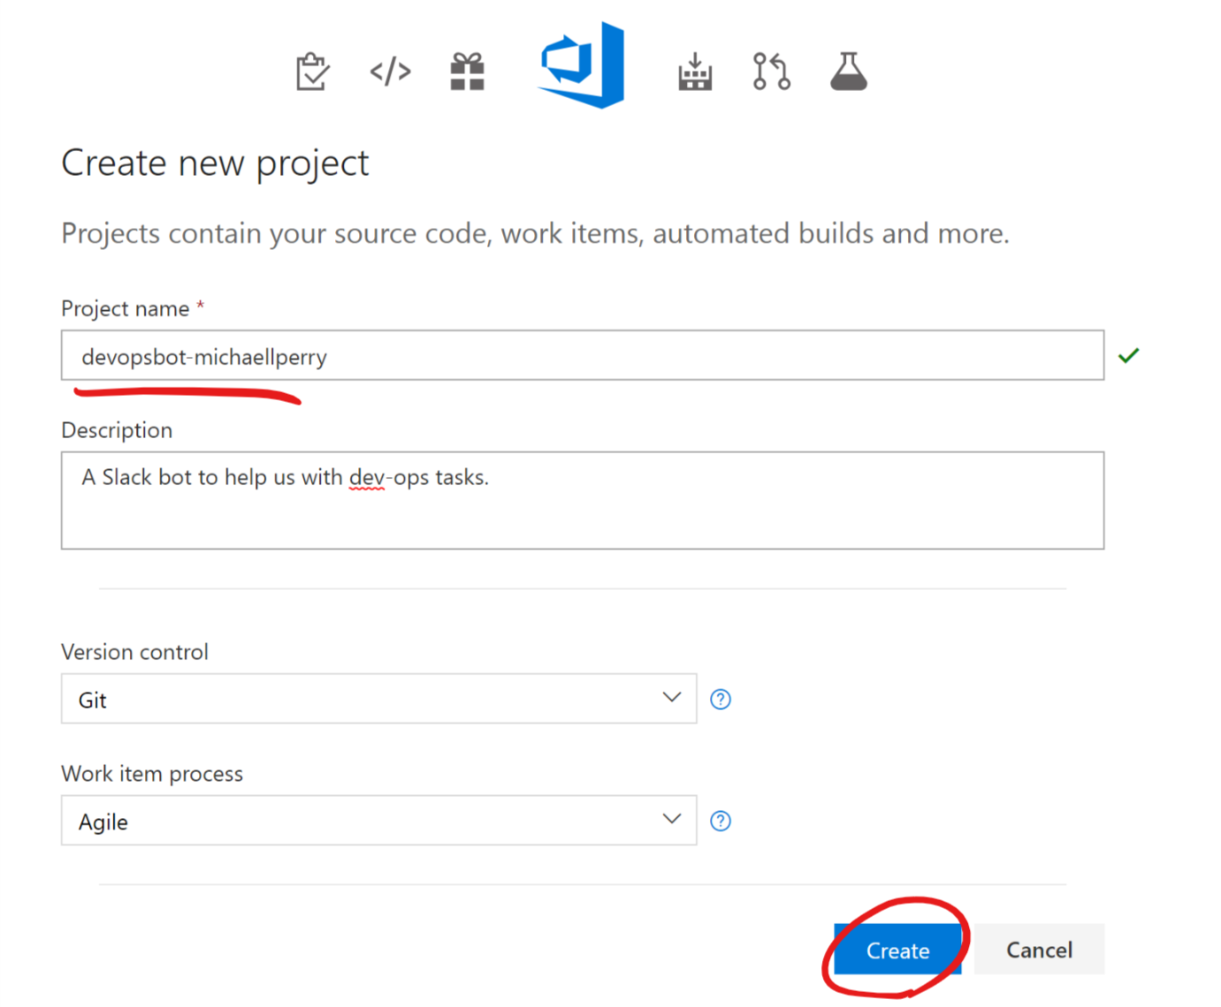

Then navigate to “Code” and click “Clone in Visual Studio”.  
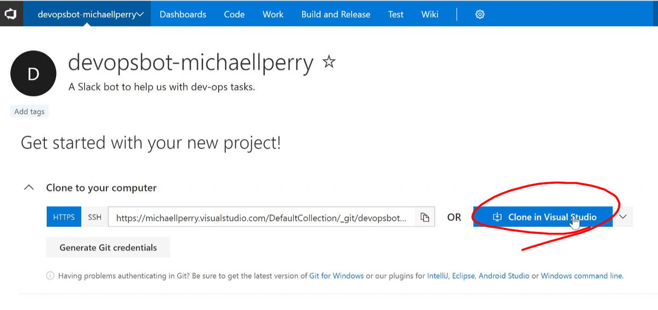

Enter a path for your project. I put mine at “C:\Projects\devopsbot-michaellperry”, since all my development projects are in this folder. Click “Clone”.  
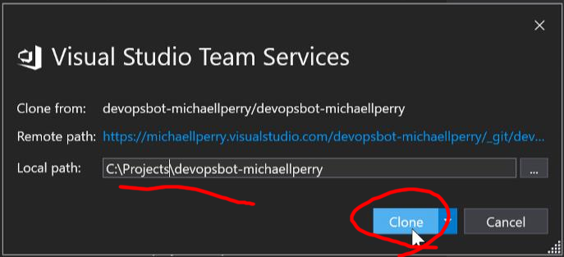

Now you have an empty folder. Download the project source code and extract it to this folder.  
Go back to Azure and open the new resource on your dashboard. Go to the “Build” section under “BOT MANAGEMENT”. We will be using continuous deployment from source control.  
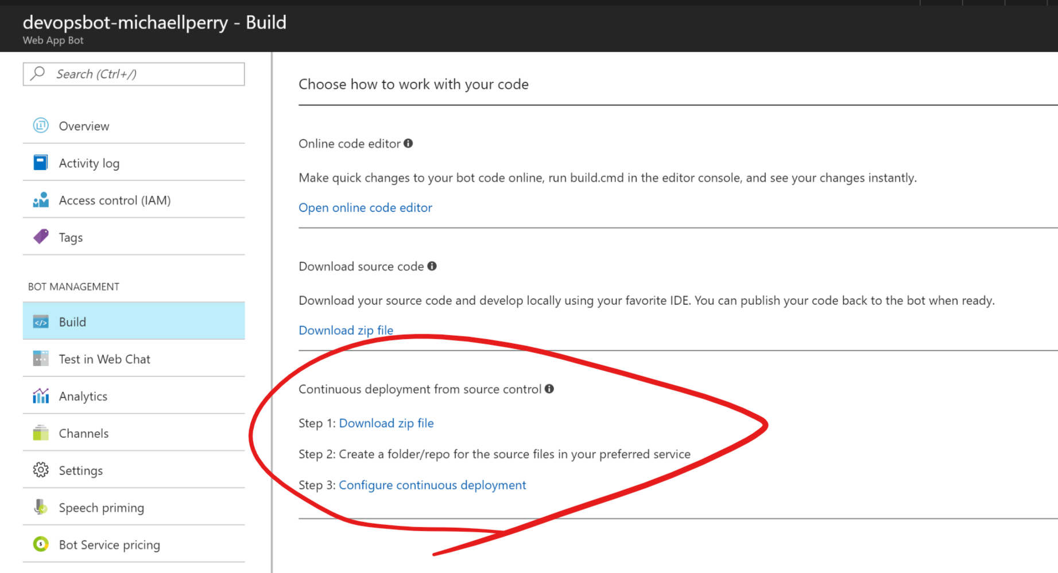

Download the zip file for your project and extract it to your empty folder. Now Visual Studio should show you the contents of this file. Double click on “Microsoft.Bot.Sample.SimpleEchoBot.sln.”  
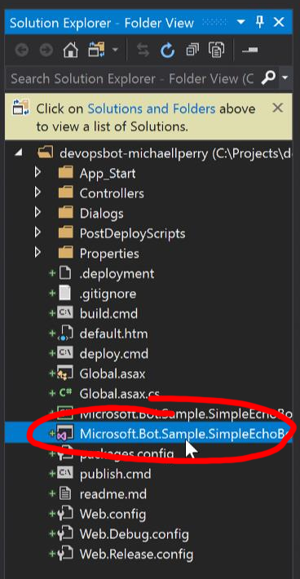

The echo bot just repeats whatever you say. You can explore the source code for a bit. Check out “Dialogs\EchoDialog.cs” to see what this bot is programmed to do. Once you’re done, let’s get this code pushed into VSTS.  
Open the Team Explorer in Visual Studio. If you don’t see it, you can hit “Ctrl+Q” to search for “team”. Go to the “Changes” section.  
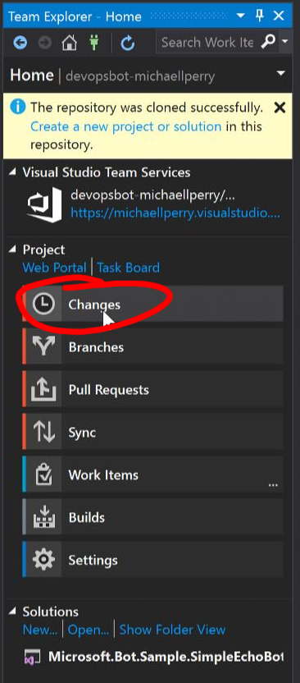

Enter a message and commit the code.  
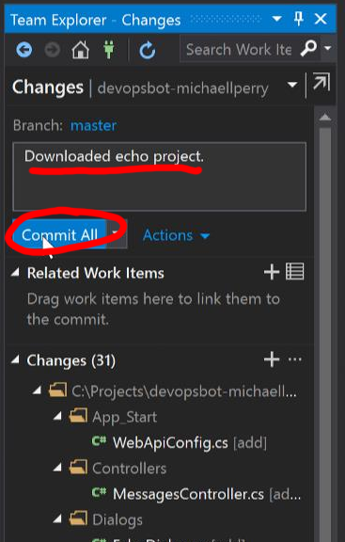

Then click “Sync” and “Push” to send it up to VSTS.  
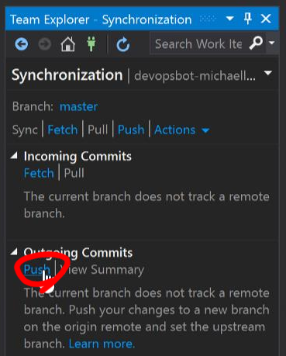

The source code for your bot is now up in VSTS. VSTS can do so much more for us, but for now we’ll just use it to hold the source. We’ll configure continuous deployment in Azure.

# Configure continuous deployment

Go back to your Azure portal. Click on “All services” and search for “team”. You want to link your VSTS account with Azure.  
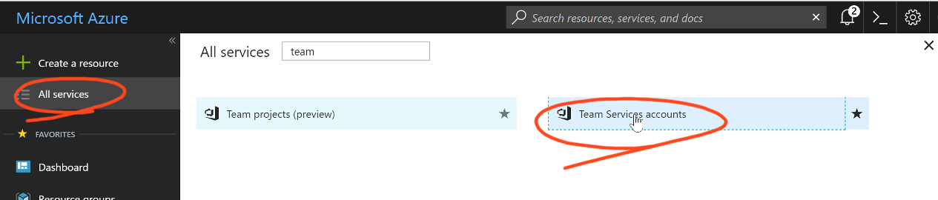

Select your VSTS account and click “Link”.  
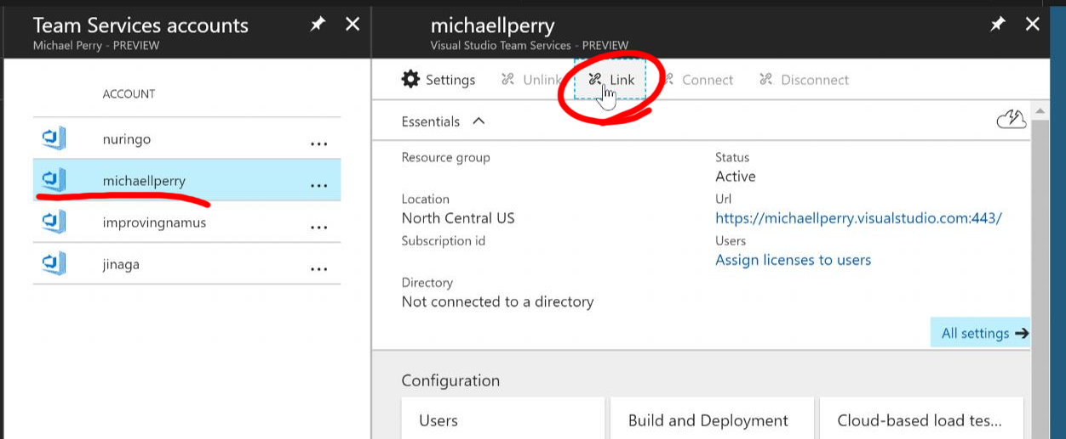

Now that your VSTS account is linked, you can use it as a source for continuous integration. Go back to your Bot (which you can access from the dashboard), and click “Build” under “BOT MANAGEMENT”. This is where we downloaded the source code. This time, click on “Configure continuous deployment”.  
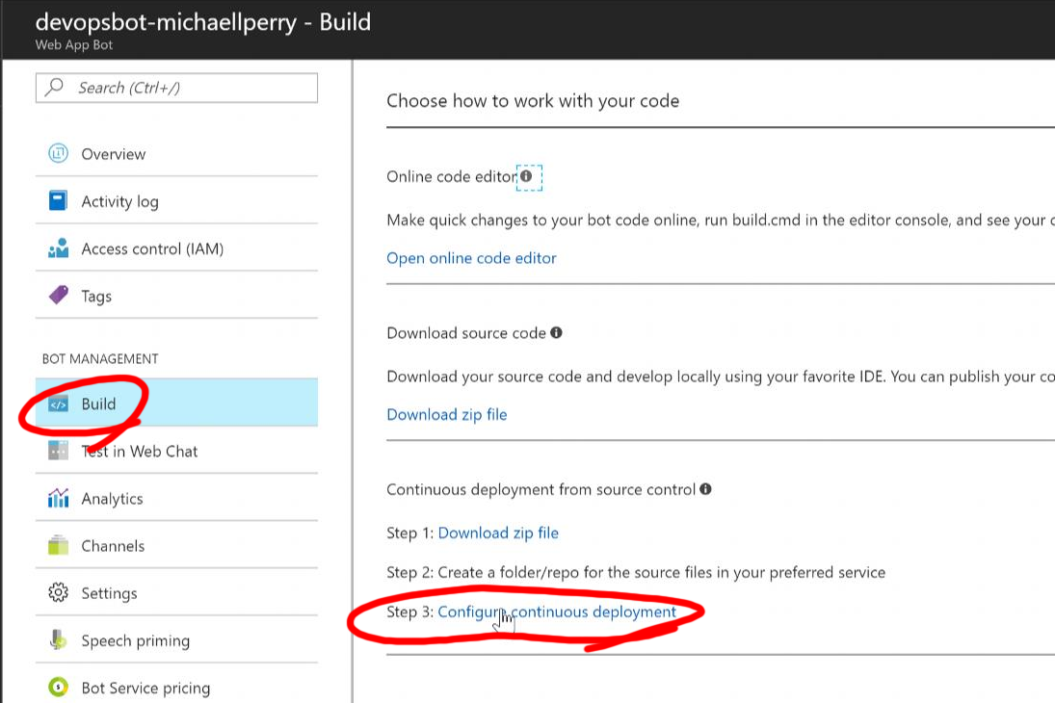

To set up your deployment, click “Setup”, “Choose Source”, and “Visual Studio Team Services”.  
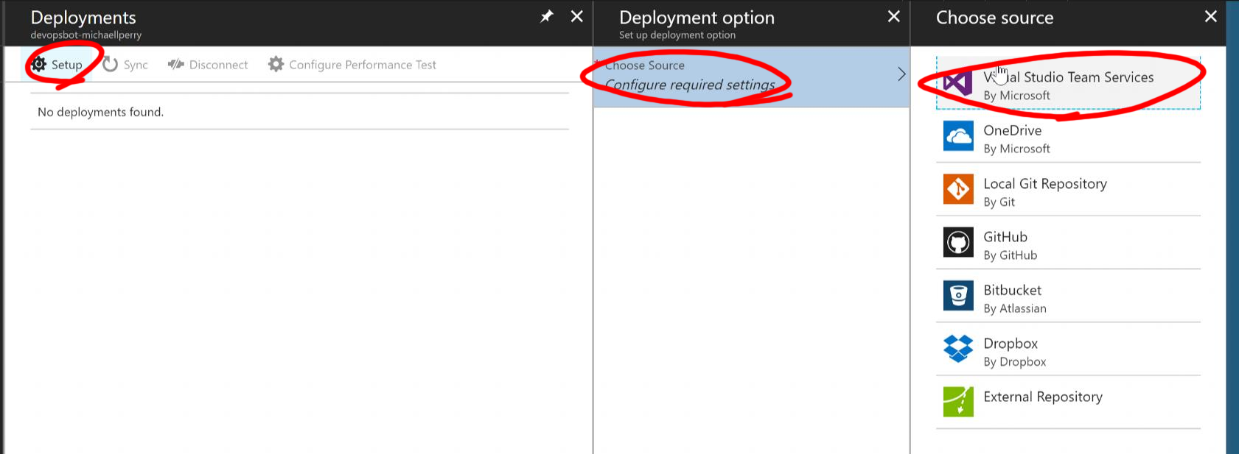

Then select your account, project, and branch (“master”). Then click “OK”.  
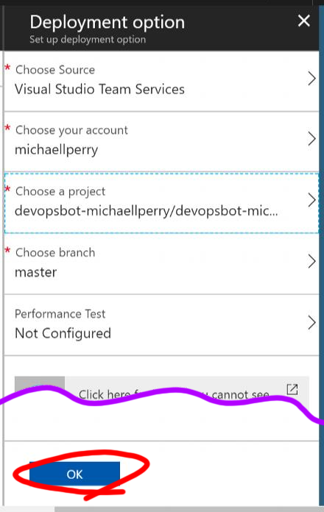

If you just hang out on this page for a few seconds, you’ll see your deployment start to build. Just wait for it to finish:  
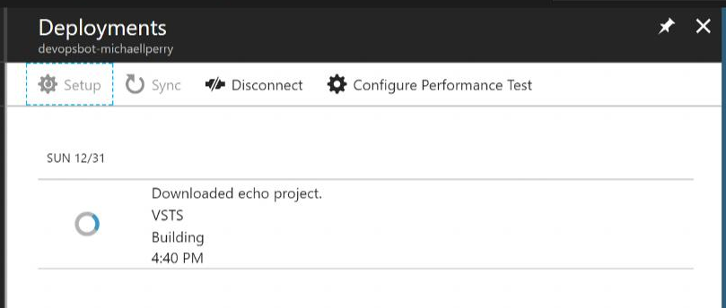

Once it builds, you can test it. Click on “Test in Web Chat” and enter a message.  
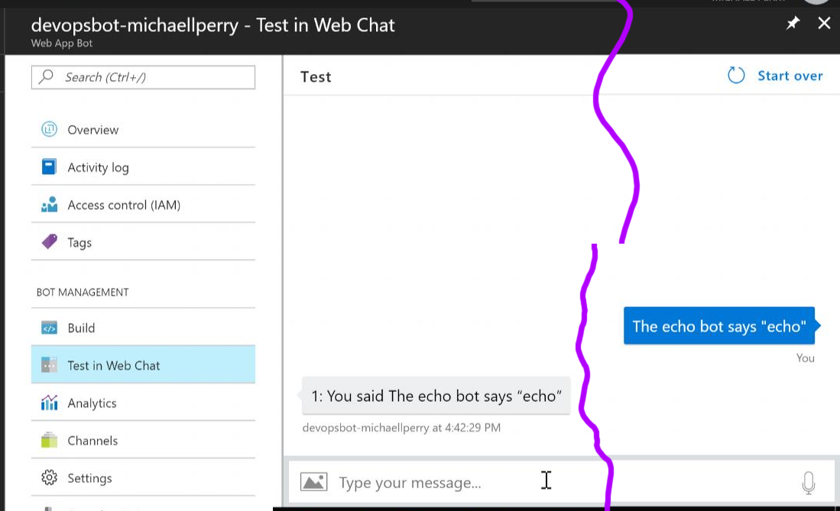

Not a very smart bot. But we’re about to change that!

# Create a natural language app

You’ll use LUIS to make your app understand natural language. Go to **https://www.luis.ai** and create an account.

Create a new app called “devopsbot-<yourname>”.  
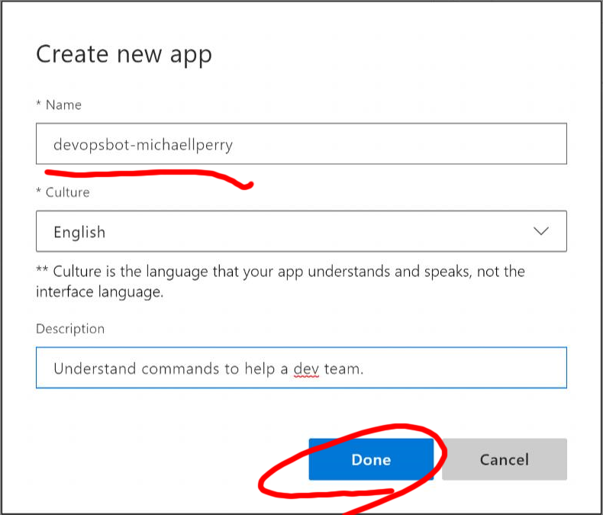

LUIS will navigate to your app so you can set up Intents. Intents are the commands that you’d like your bot to understand. You train a new intent by providing example utterances. We’ll start with an intent called “ListBuilds” that recognizes utterances such as “What builds have finished?”  
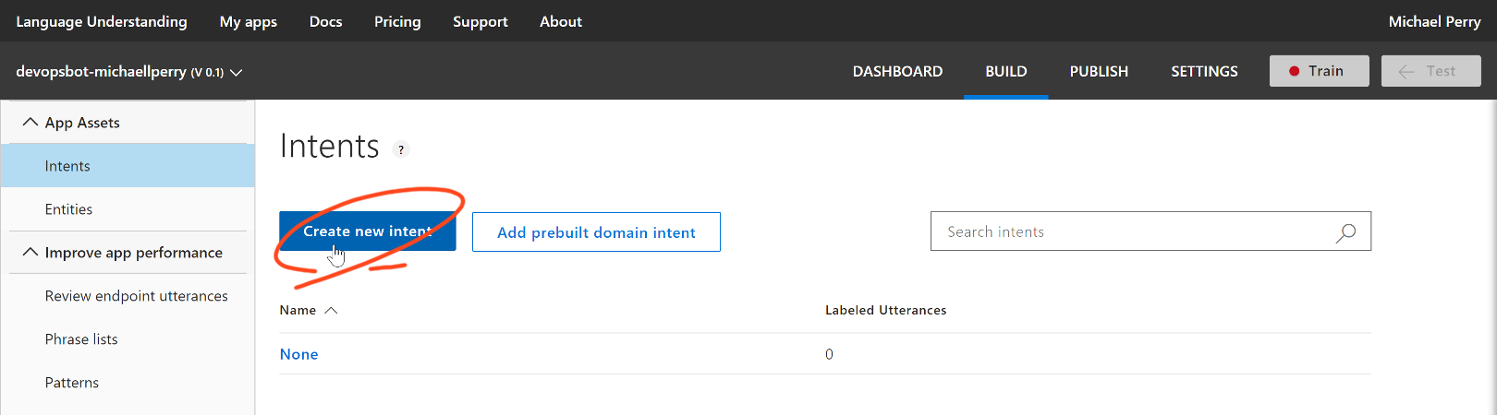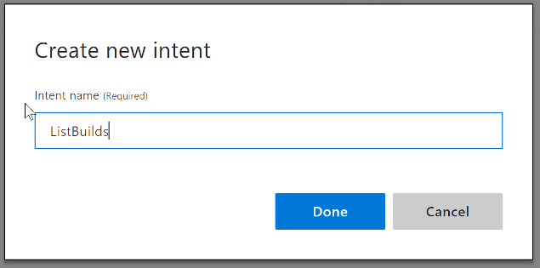

Provide a few utterances for the intent. Just type in the box and hit enter.  
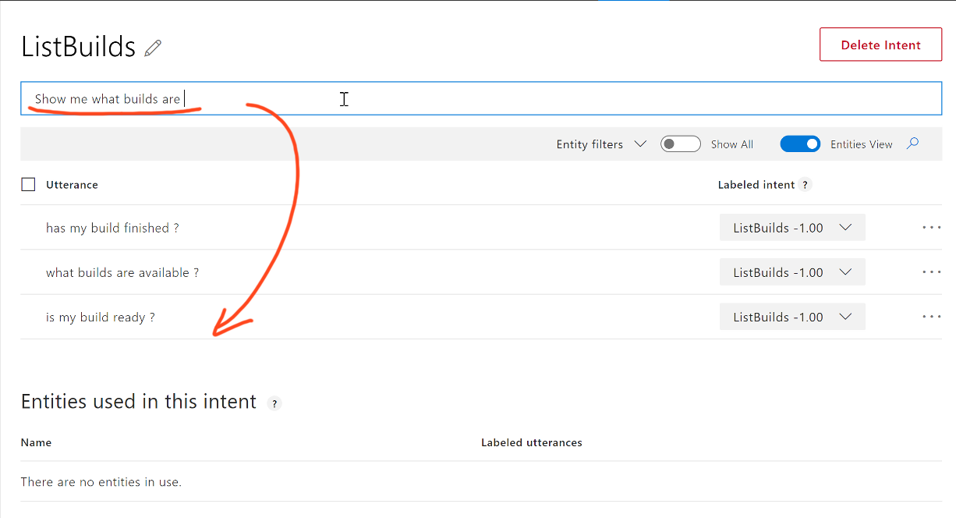

Now it’s time to train your app. Click the “Train” button.   
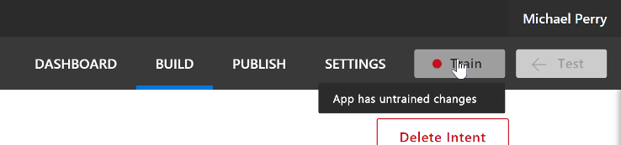

After training comes testing. Click the “Test” button to open the test panel. Type an utterance similar to the one’s you’ve trained it with. Notice the top scoring intent.  
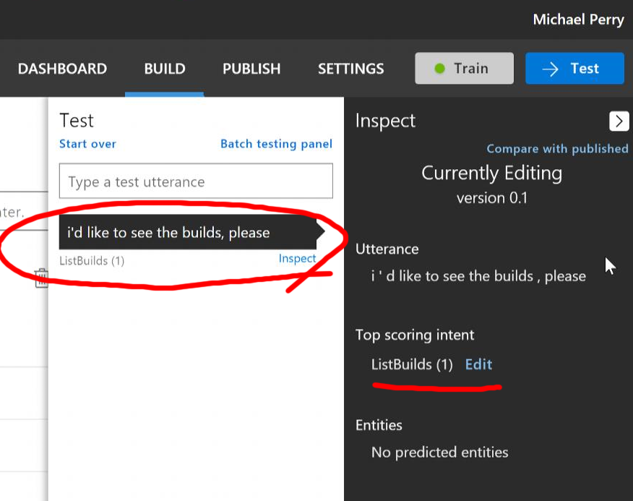

Now that we’re happy that LUIS understands our intent, it’s time to publish the app. Click “Publish”, and Publish again.  
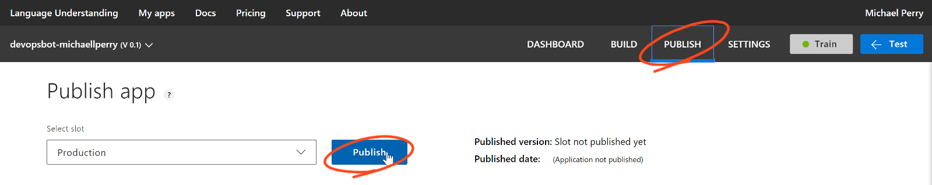

That will deploy your LUIS app (not your bot) to an endpoint listed at the bottom of the page. Click on this endpoint to open it in a browser.  
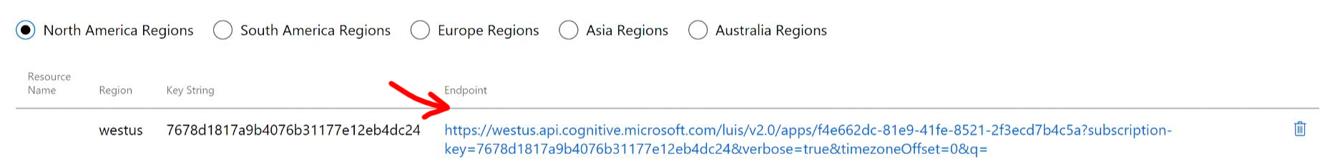

At the very end of the URL you’ll see a “q=” query string parameter. This is the utterance that you want LUIS to understand. Type a simple utterance using plus for spaces.  
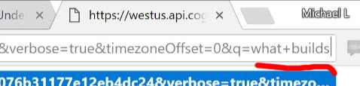

LUIS will interpret the utterance and show you the top scoring intent.  
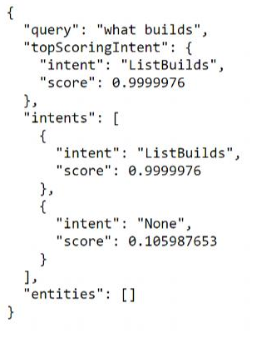

Now we just need the bot to call LUIS to interpret the intent. To the codez!

# Write a LUIS dialog

Before you start modifying the code, make sure it compiles for you. You might need to open the NuGet package manger and restore all of the packages.

In the Bot Framework, the unit of interaction is called a “dialog”. This is a conversation that starts with a message and optionally continues until some goal is reached. We’ve already seen one example: the EchoDialog. Now let’s create a dialog to call the LUIS app. Fortunately, there’s a base class that makes it really easy.

Create a new class in the Dialogs folder called DevOpsDialog. Mark this class [Serializable] and inherit from LuisDialog<object>. This base class can be found in Microsoft.Bot.Builder.Dialogs.

using Microsoft.Bot.Builder.Dialogs;  
using System;  
  
namespace SimpleEchoBot.Dialogs  
{  
 [Serializable]  
 public class DevOpsDialog : LuisDialog<object>  
 {  
 }  
}

To call the base class constructor, you’ll need a LuisService. Construct one by getting the LuisAppID and LuisAPIKey from web.config.

using Microsoft.Bot.Builder.Dialogs;  
using Microsoft.Bot.Builder.Luis;  
using System;  
using System.Configuration;  
  
namespace SimpleEchoBot.Dialogs  
{  
 [Serializable]  
 public class DevOpsDialog : LuisDialog<object>  
 {  
 public DevOpsDialog() : base(CreateLuisService())  
 {  
 }  
  
 private static ILuisService CreateLuisService()  
 {  
 string appId = ConfigurationManager.AppSettings["LuisAppId"];  
 string apiKey = ConfigurationManager.AppSettings["LuisAPIKey"];  
 var luisModel = new LuisModelAttribute(appId, apiKey);  
 return new LuisService(luisModel);  
 }  
 }  
}

I don’t know why this is an attribute. Maybe they expect you to put the app ID and API key directly in source code in an attribute attached to the class. Don’t do that, please.

Instead, go to web.config and add a couple of application settings. You will find two already in appSettings.

<appSettings>  
 <!-- update these with your Microsoft App Id and your Microsoft App Password-->  
 <add key="MicrosoftAppId" value="" />  
 <add key="MicrosoftAppPassword" value="" />  
 <add key="LuisAppId" value=""/>  
 <add key="LuisAPIKey" value=""/>  
 </appSettings>

Don’t put values in this file! This is a placeholder for the deployed application. Put those secrets in Azure!

Let’s go get those secrets. Open up KeePass2 so we can store them securely. Create a new database if you haven’t already. Instructions are in the prerequisites document.

Go back to https://www.luis.ai and go to your application. Click on “Settings” in the menu and copy the Application ID. Paste that into a new KeyPass entry as the user name.  
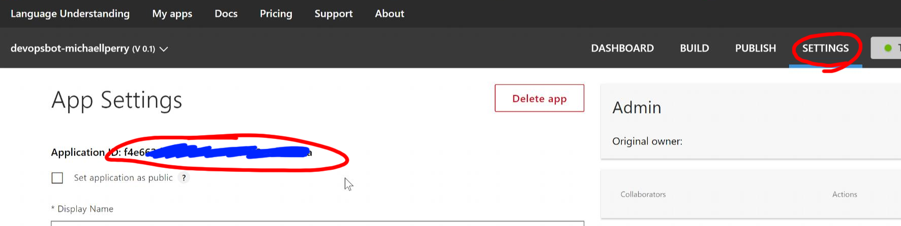

Then click on your name in the upper right-hand corner and select “Settings”. Copy the Authoring Key from the user settings and paste that in as the password.  
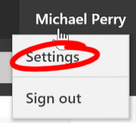 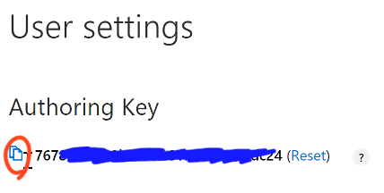  
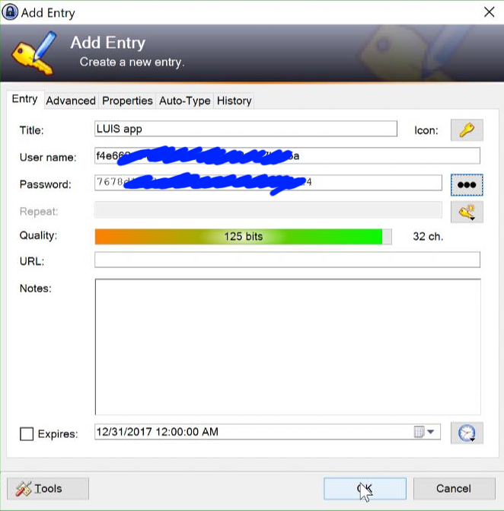

Save the entry, and then save the database. Now go to the Azure portal and paste these into Application Settings.

On the portal, open your bot resource. Click on “Application Settings”, and scroll down to the App settings section. Add new settings for LuisAppId and LuisAPIKey. Click “Save”.  
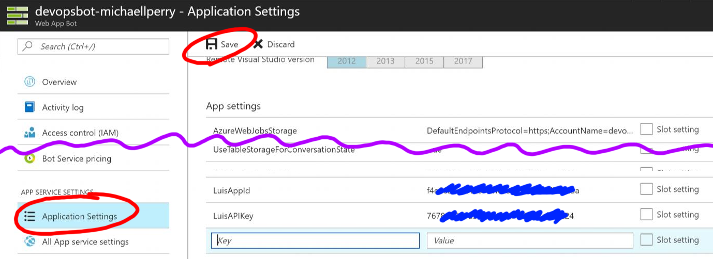

This puts your secrets in the cloud, where they are needed. But it keeps your source code repository nice and clean. No secrets will leak out.

Let’s add some code to the DevOpsDialog to handle the ListBuilds intent. Do this by defining a new method using the LuisIntent attribute.

[LuisIntent("ListBuilds")]  
public async Task ListBulidsIntent(IDialogContext context, LuisResult result)  
{  
 await context.PostAsync("Let me list those builds for you.");  
 context.Wait(MessageReceived);  
}

Create another method to handle the None intent.

[LuisIntent("None")]  
public async Task NoneIntent(IDialogContext context, LuisResult result)  
{  
 await context.PostAsync($"You said: {result.Query}. I don't know how to do that.");  
 context.Wait(MessageReceived);  
}

The method signature is very important. Double-check your work!

Commit and push your work, just like we did the first time. Then if you’re fast enough, you can switch over to Azure, go to “All App service settings”, “Deployment options”, and watch your build. Once it’s finished, go back to the first menu and click “Test in Web Chat” to try it out.  
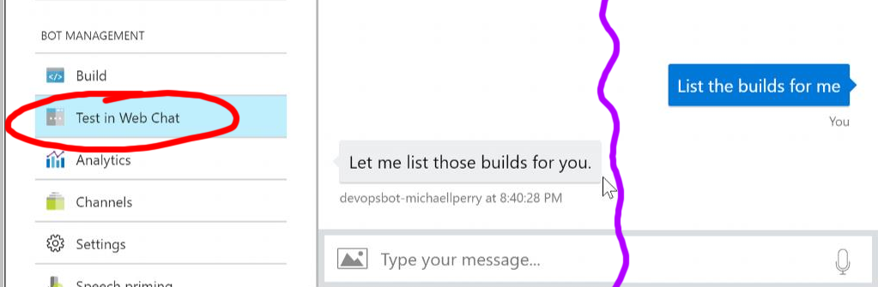

You have a working bot!

# Debug your bot (optional)

Your bot is running in the cloud. But you want to set a breakpoint. So what can you do? Turn on remote debugging!

Go to the Azure portal, open your bot, and click “Application settings”. Inside of Application Settings, you can turn on remote debugging. Then click “Save”.  
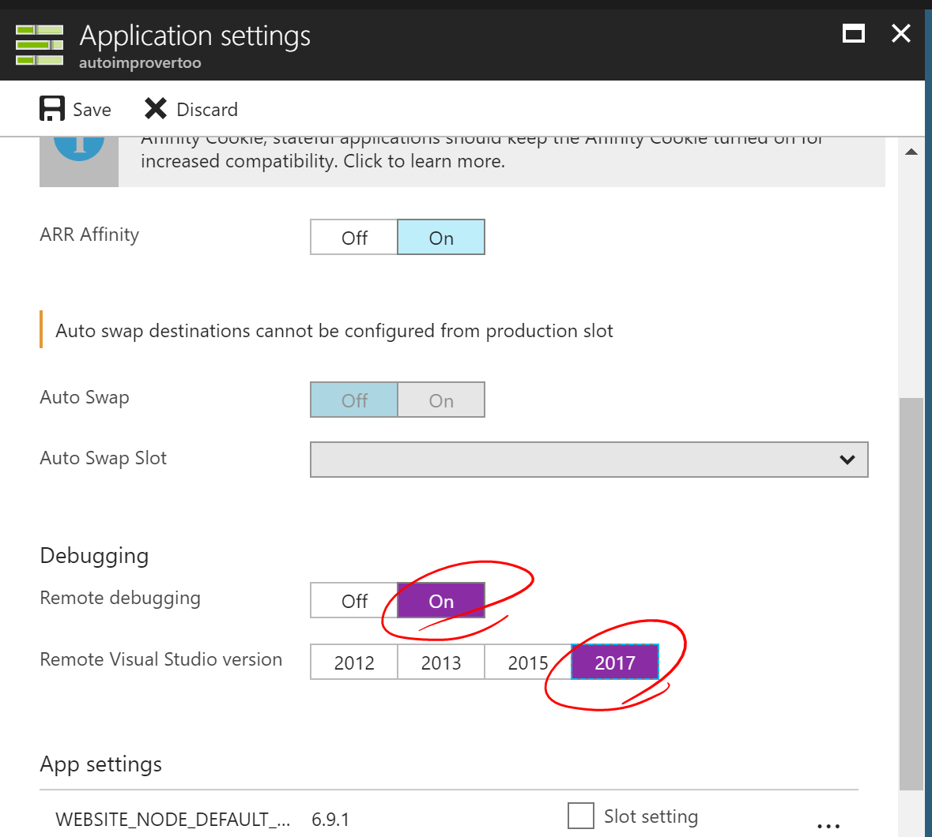

Now you can open the Cloud Explorer in Visual Studio. It’s in the View menu.  
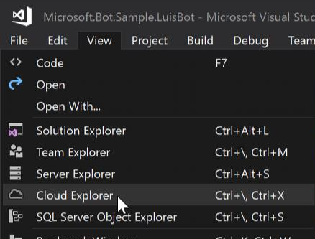

In the Could Explorer, click Manage Accounts. Log in to your Azure account. Then select your subscription. Click “Apply”.  
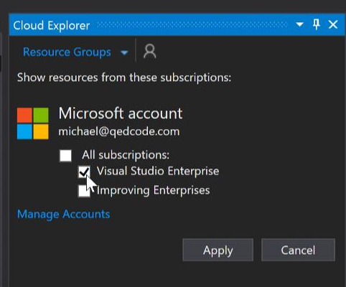

Now you can drill down to your application. Click on the app, and the Action panel will appear. One of these actions is “Attach Debugger”. Really!!!  
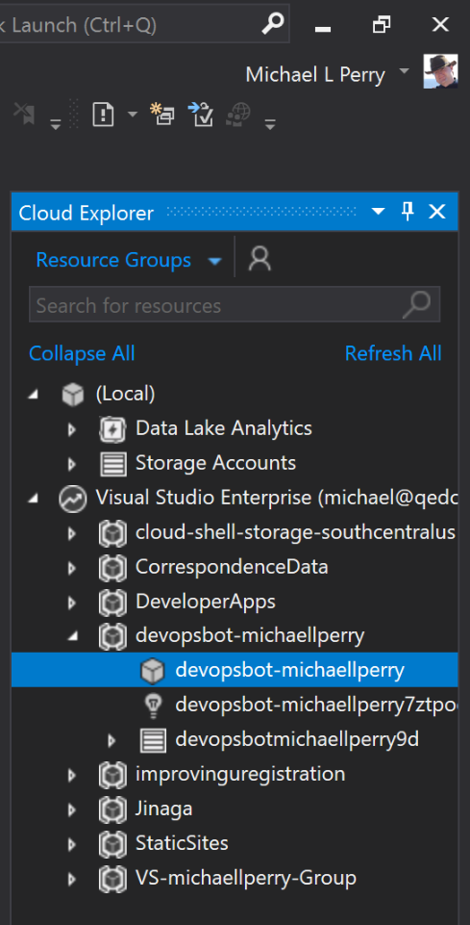 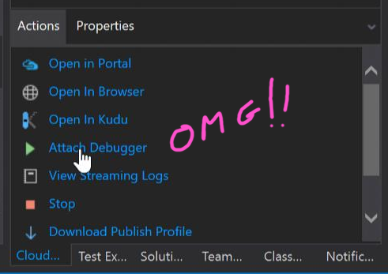

Your bot will start up. It doesn’t have a UI. It’s expected to be called via the API. We’ll use the Test pane to call it. But first, flip back to Visual Studio and notice that you need to turn off Just My Code, since we are debugging with a release build.  
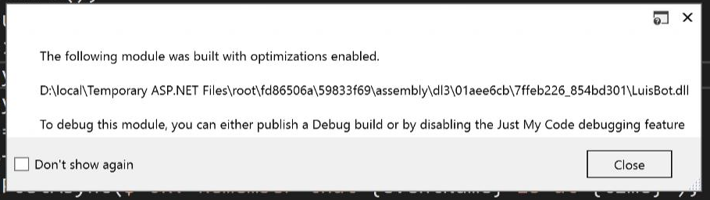 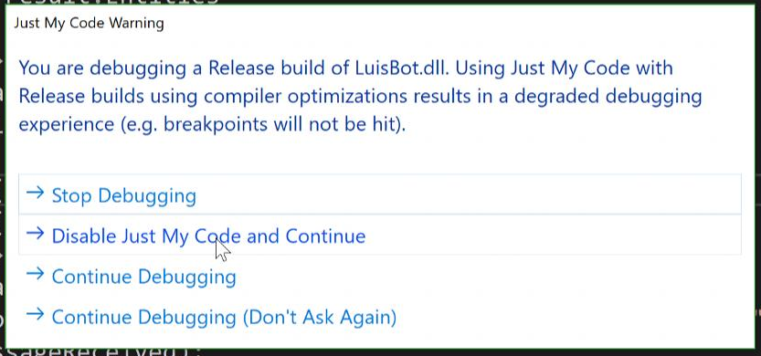

Now set a breakpoint in the ListBuildsIntent method and it will get hit. From the cloud! How cool is that?! So we need to trigger it. Go back to Azure, open the bot, and go back to “Test in Web Chat”. Type a message.

When you hit enter, your breakpoint will be hit. Debugging from the cloud is a little slow. Be patient. It’s going to space! If you want a faster way to debug bots, you can install the Bot Framework Emulator (<https://docs.microsoft.com/en-us/bot-framework/debug-bots-emulator>). But we won’t be going through that in this workshop.

You’ve set up all of the services in the Microsoft Bot Framework. Now customize your bot, configure it to respond on Slack, and set it up to monitor your CI build.

# Attach Your Bot to Slack

The Bot Framework has integrations with several different chat tools and protocols. Assuming that your dev team is already on Slack, you’ll invite your bot to join your Slack team.

Start at your Slack account. Sign in. Then browse to https://api.slack.com, and click “Start Building”. Create a Slack app with the name “devopsbot” in your workspace.  
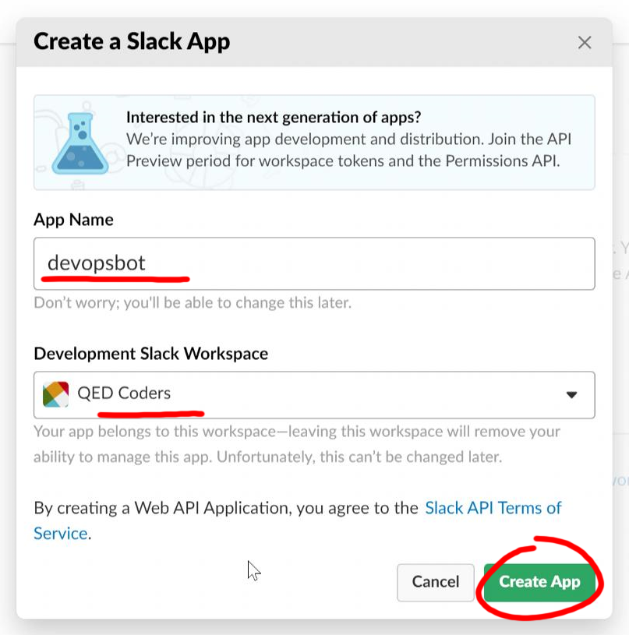

This will take you to the “Basic Information” page about your app. Scroll down to “App Credentials” and copy these values into a new KeyPass2 entry.  
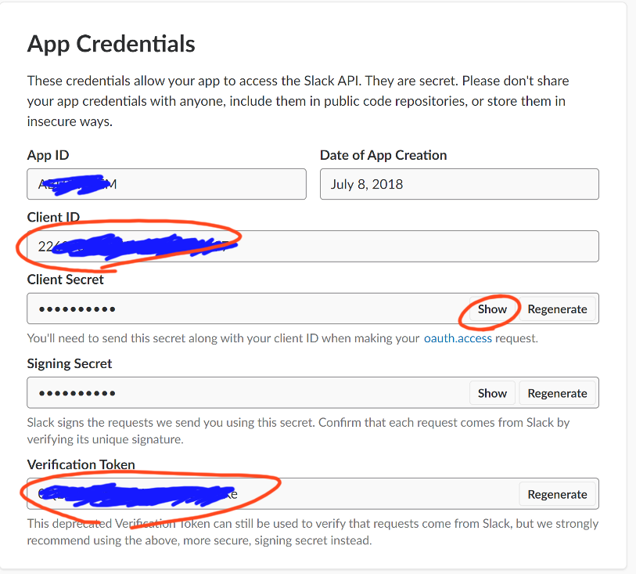

Save your entry.  
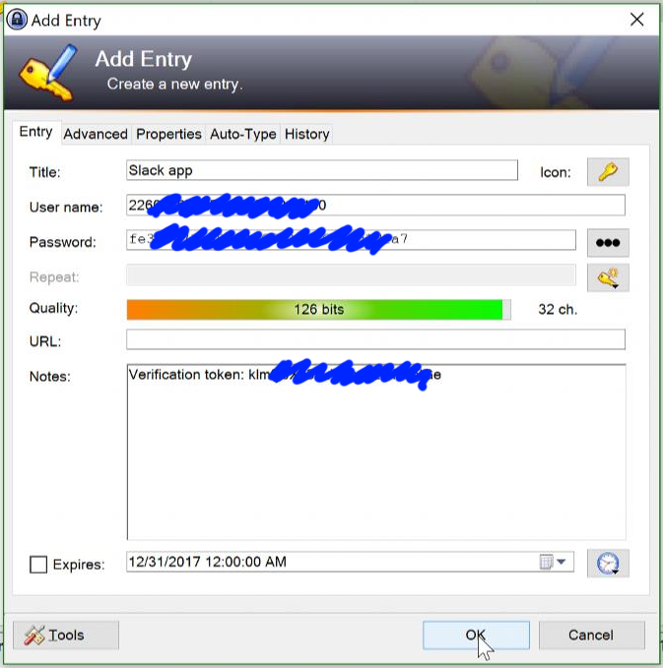

Configuring your Slack app by clicking “OAuth & Permissions”. Add a redirect URL for “https://slack.botframework.com/Dev/Validate”. Click “Save URLs”.  
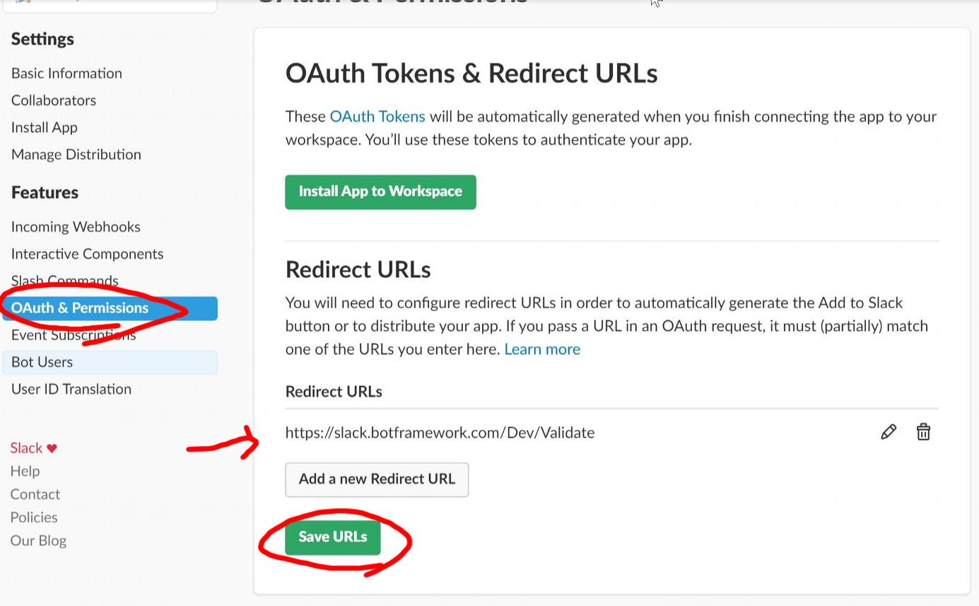

Scroll down to “Select Permission Scopes”. Your app will need to create a bot user and send messages as that user. Add these two permissions and click “Save Changes”.  
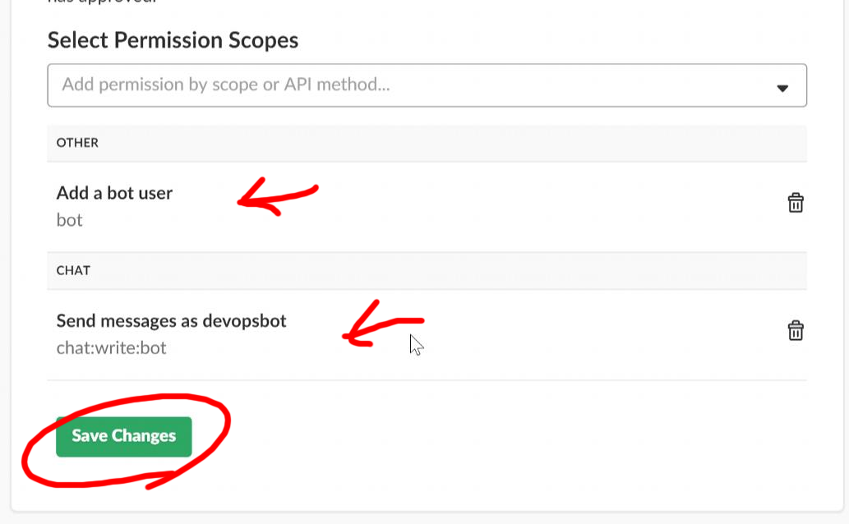

Speaking of bot users, let’s configure that next. Click on “Bot Users” and add a bot user. Take the defaults and just click “Add Bot User”.  
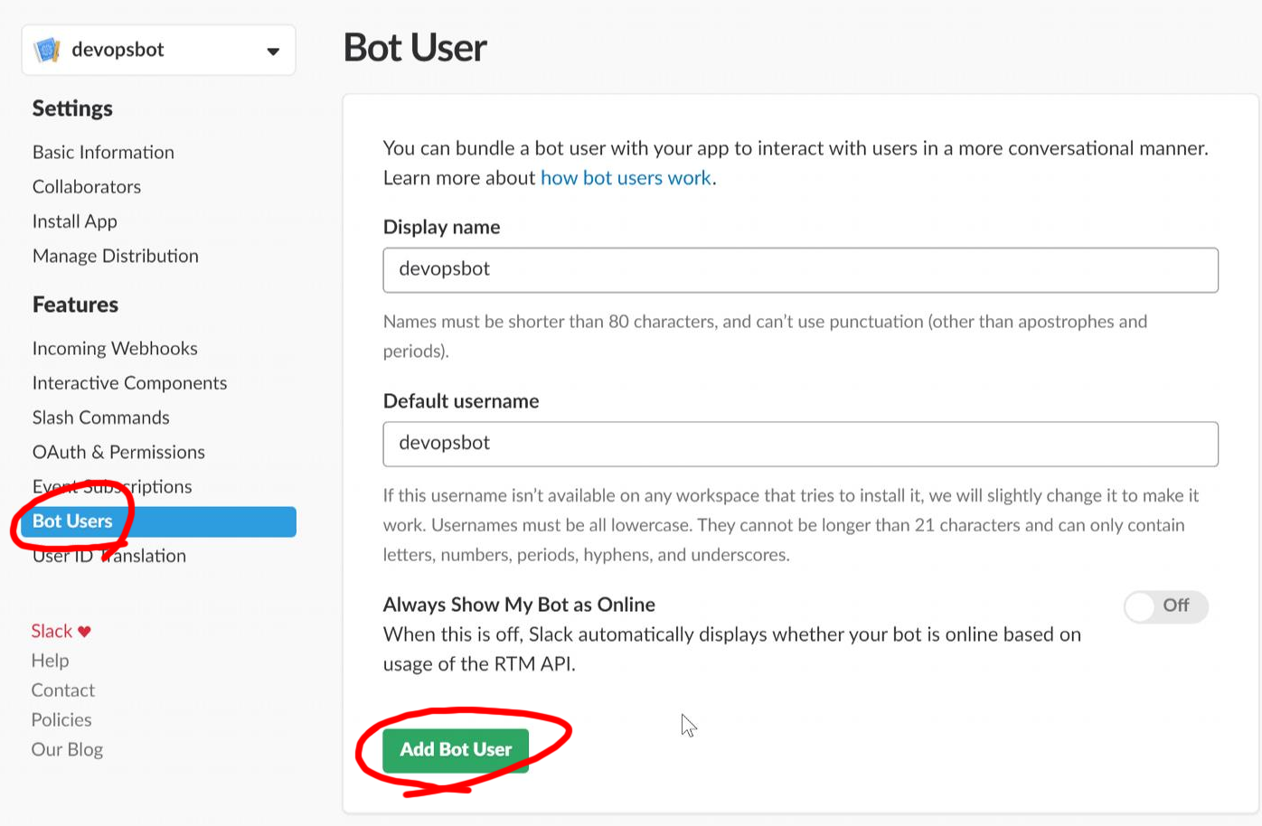

Next open up “Event Subscriptions” and enable events. Set the Request URL to “https://slack.botframework.com/api/Events/devopsbot-{yourname}”.  
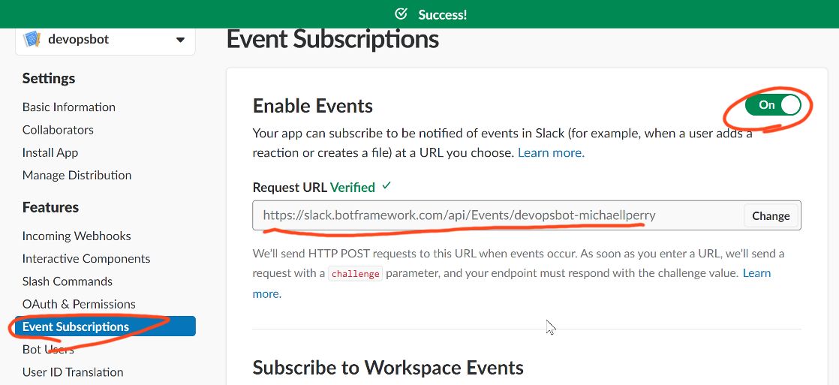

Subscribe to the following events:

* member_joined_channel
* member_left_channel
* message.channels
* message.groups
* message.im
* message.mpim

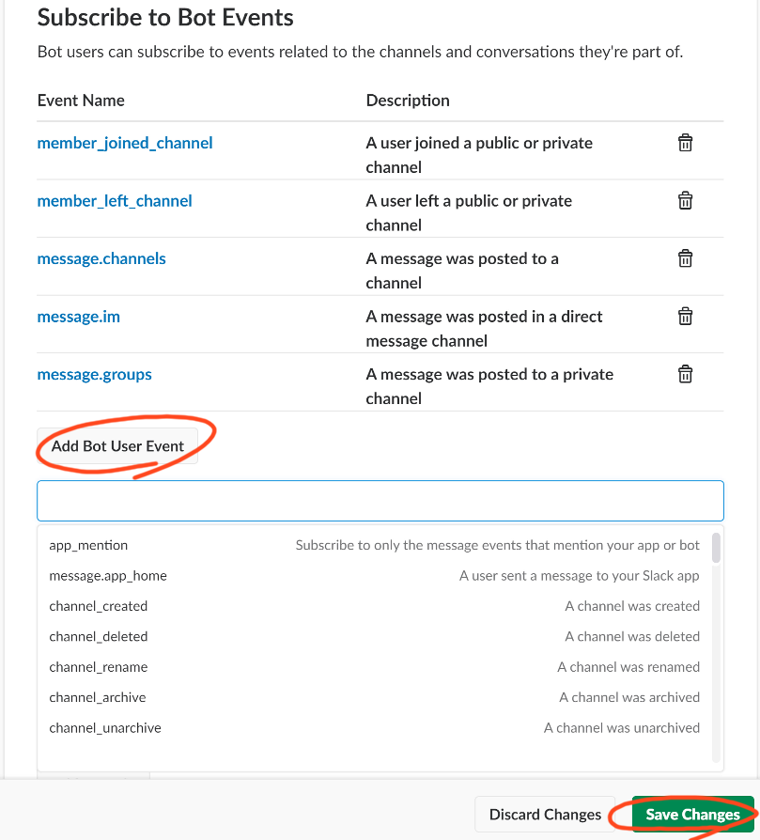

Now that Slack is set up for your app, you need to connect the brain. Go back to the Azure portal, open your bot, and click “Channels”.   
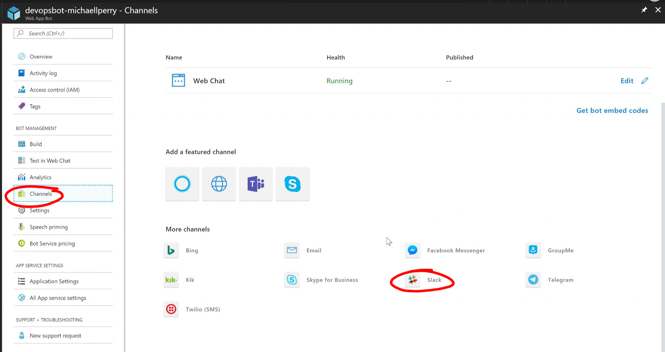

Paste in the Slack credentials that you copied to KeePass2. Then click “Save”.  
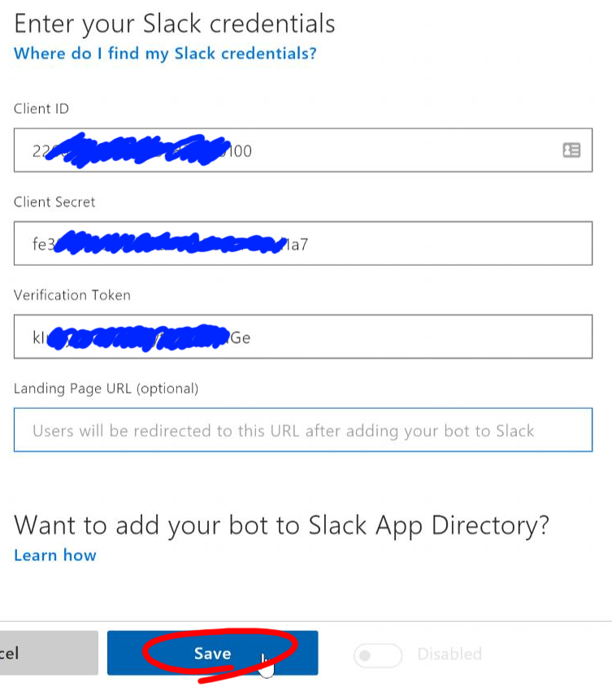

Azure will add the bot to Slack. Slack will confirm that you authorize it to join your workspace:  
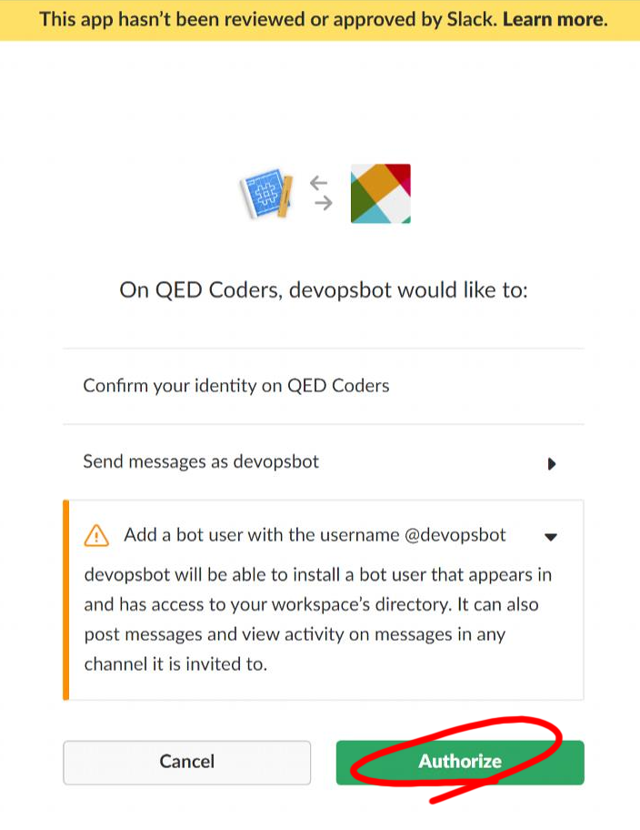

Now that it’s there, go back to your workspace and mention @devopsbot. Invite them to join.  
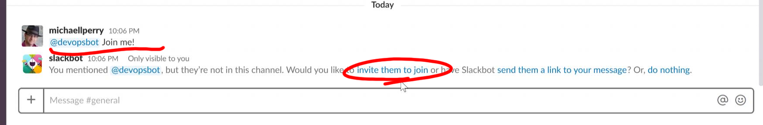

Now enter the magic utterance. Devopsbot will respond!  
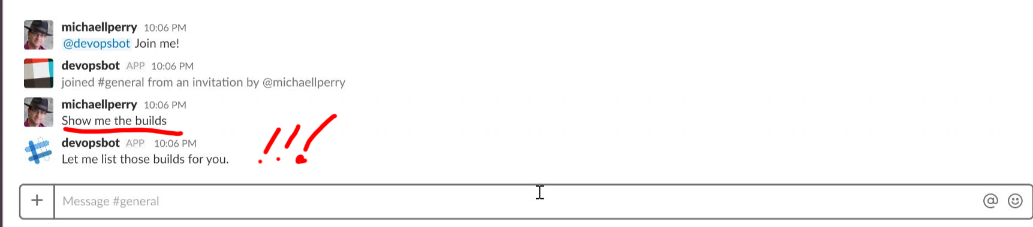

The bot will respond to everything anyone says in #General. Of course, this might get annoying. So let’s enforce the cardinal rule of chat bots.

# Speak Only When Spoken To

A bot in the #General channel responding to every utterance will be quickly booted out. One solution would be to invite the bot to a special room. Then everyone would have to go to that room to interact with the bot. I’d prefer to have a bot as a member of the team, collaborating helpfully where the team already lives. So I’d like the bot to only respond when I address it.

The MessagesController receives a POST whenever the Bot Framework notifies it of an activity. When this activity is a Message, it will include some Text. We can examine this text using a debugger to see what it looks like when the user addresses the bot. To save you some time, I can say that it will contain the text “@devopsbot”, assuming that that is the default username that you assigned.

Configure BotUserName as an application setting in web.config.

<add key="BotUserName" value="devopsbot"/>

Then you can use the following code to load it in to the application.

private readonly string _botUserName;

public MessagesController()

{

_botUserName = ConfigurationManager.AppSettings["BotUserName"];

}

Then add this method to MessagesController to determine if the bot is being spoken to.

private bool SpokenTo(string text)

{

return text.Contains($"@{_botUserName}");

}

private string RemoveAddress(string text)

{

return text.Replace($"@{_botUserName}", "");

}

That second method will remove the text that addresses the bot. Use these methods in Post to only process messages that address the bot, and to preprocess the text.

// check if activity is of type message

if (activity != null && activity.GetActivityType() == ActivityTypes.Message)

{

if (SpokenTo(activity.Text))

{

activity.Text = RemoveAddress(activity.Text);

await Conversation.SendAsync(activity, () => new DevOpsDialog());

}

}

Commit and push the code change to have the bot built and deployed. Now it will only respond when you address it directly.  
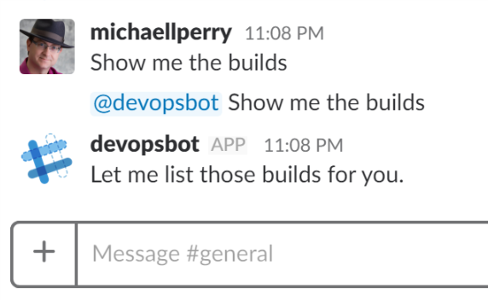

# List CI Builds

Now let’s make the bot actually do some work for you. It can recognize when you ask it to list the builds from the CI server. Now let’s configure it to actually do so. We’ll have it monitor CI builds in VSTS.

Talking to VSTS can take some time. To avoid timing out, we should respond immediately to Slack, and then go off and do some work. For that, we’ll need to use a conversation reference.

A conversation reference holds the information necessary to get back to a long running conversation. We’ll pass this conversation reference into an object that works on a background task. When it has completed its work, it will use the conversation reference to respond on the previously started conversation. The essential code is as follows:

private async Task Respond(string text)

{

var post = _conversationReference.GetPostToBotMessage();

var reply = post.CreateReply(text);

var client = new ConnectorClient(new Uri(post.ServiceUrl));

await client.Conversations.ReplyToActivityAsync(reply);

}

I’ve encapsulated this code in a helpful base class called BackgroundTask. You can find the code at <https://github.com/michaellperry/autoimprover/blob/master/Tasks/BackgroundTask.cs>. Add this class to your project. Then create a new class called ListBuilds in a new Tasks folder. Inherit BackgroundTask.

public class ListBuilds : BackgroundTask

{

public ListBuilds(ConversationReference conversationReference) :

base(conversationReference, "listing builds")

{

}

protected override Task Process()

{

throw new NotImplementedException();

}

}

Create and start a new instance of this background task from the ListBuilds intent.

[LuisIntent("ListBuilds")]

public async Task ListBuilds(IDialogContext context, LuisResult result)

{

await context.PostAsync("OK. Let me get those builds for you...");

new ListBuilds(context.Activity.ToConversationReference()).Start();

context.Wait(MessageReceived);

}

To list the builds, you’ll connect to VSTS. I’ve created a pair of helper classes for you. Download these classes from GitHub and add them to your project.

https://github.com/michaellperry/autoimprover/blob/master/Tasks/SourceControl/VstsClient.cs

https://github.com/michaellperry/autoimprover/blob/master/Tasks/SourceControl/Build.cs

Then us it in your Process method.

protected override async Task Process()

{

var vstsClient = new VstsClient();

var builds = await vstsClient.ListBuilds();

string buildsFormatted = builds

.Select(b => $"{b.BuildNumber,-12}{b.Result,-11}{b.For,-20}{b.FinishTime:g}")

.Aggregate("", (prior, current) => $"{prior}\n{current}");

await Respond($"I found {builds.Count} builds:\n```{buildsFormatted}```");

}

Add the following app settings to web.config. We will go over the steps for determining these values:

<add key="VstsTeamName" value=""/>

<add key="VstsProjectName" value=""/>

<add key="VstsAccessToken" value=""/>

<add key="VstsBuildDefinition" value=""/>

The idea is that this will be the CI for your team’s project, not for the bot itself. For this lab, let’s set up a new project that we can monitor.

Go to your VSTS account (mine is <https://michaellperry.visualstudio.com>) and create a new project. Name it “OurProject” and give it a description. Then click “Create”.  
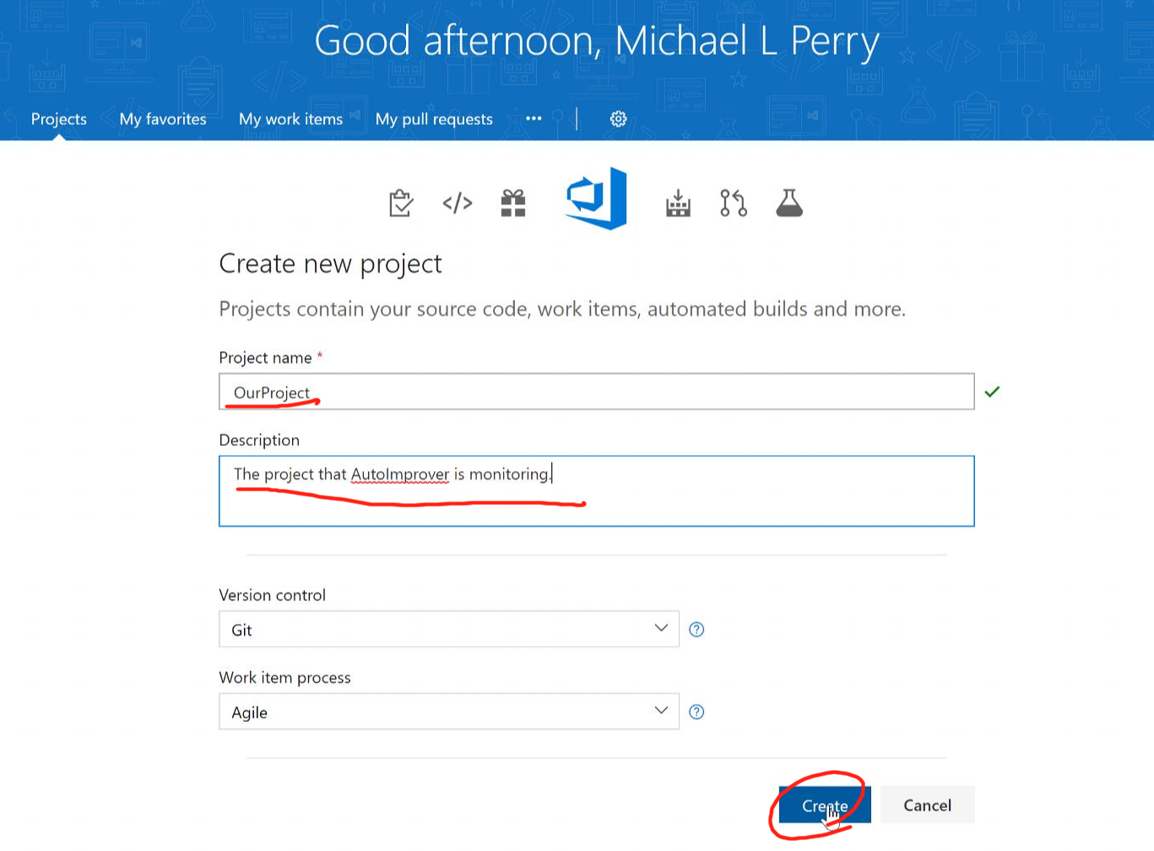

In Visual Studio, create a new ASP.NET Web Application. Enter the name OurProject and put it in your favorite projects folder. Be sure to check the box to create a new Git repository. Click “OK”.  
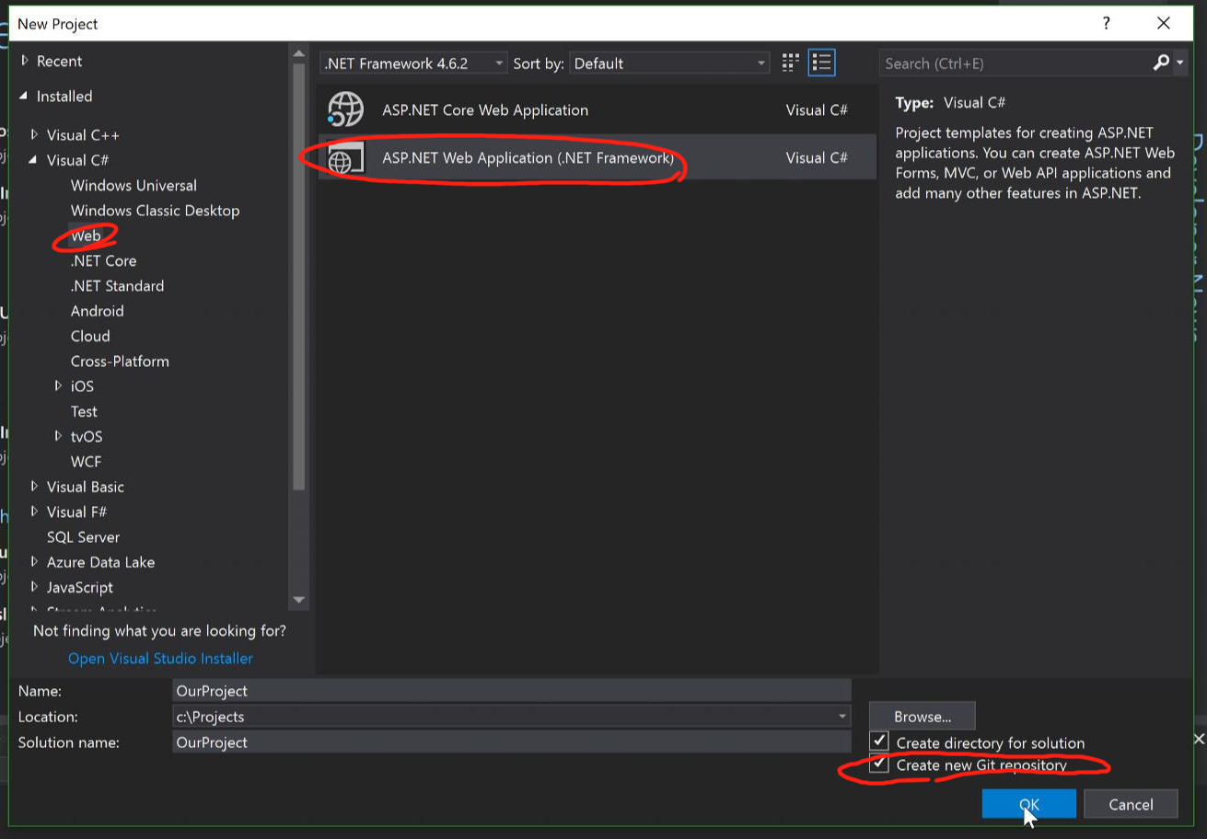

Select an MVC project. Check the box to add unit tests. Then click “OK”.  
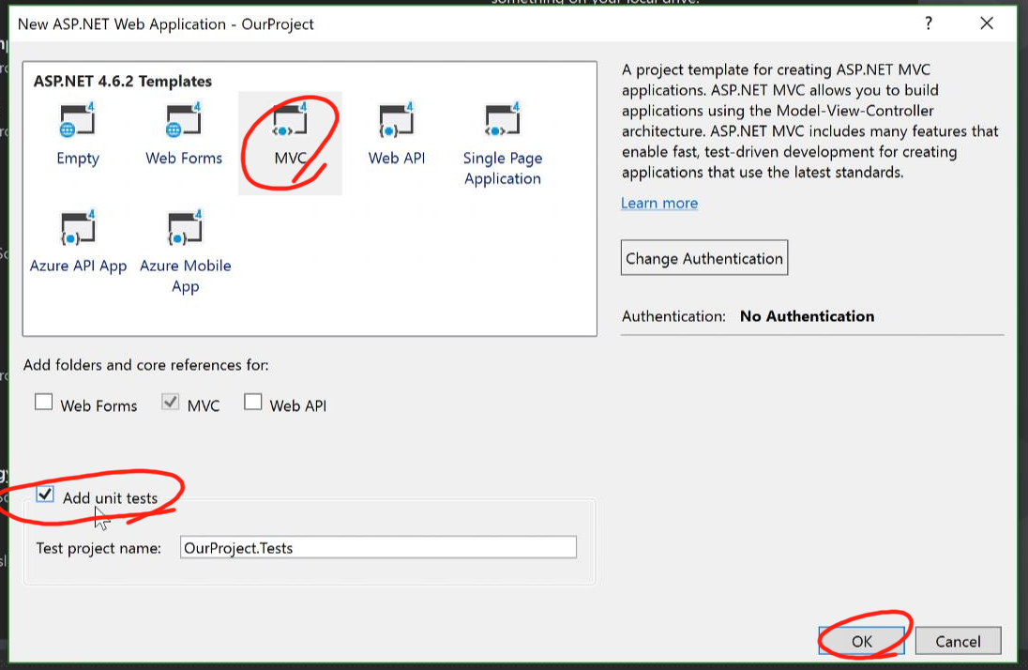

Now go back to VSTS and copy the HTTPS clone URL.  
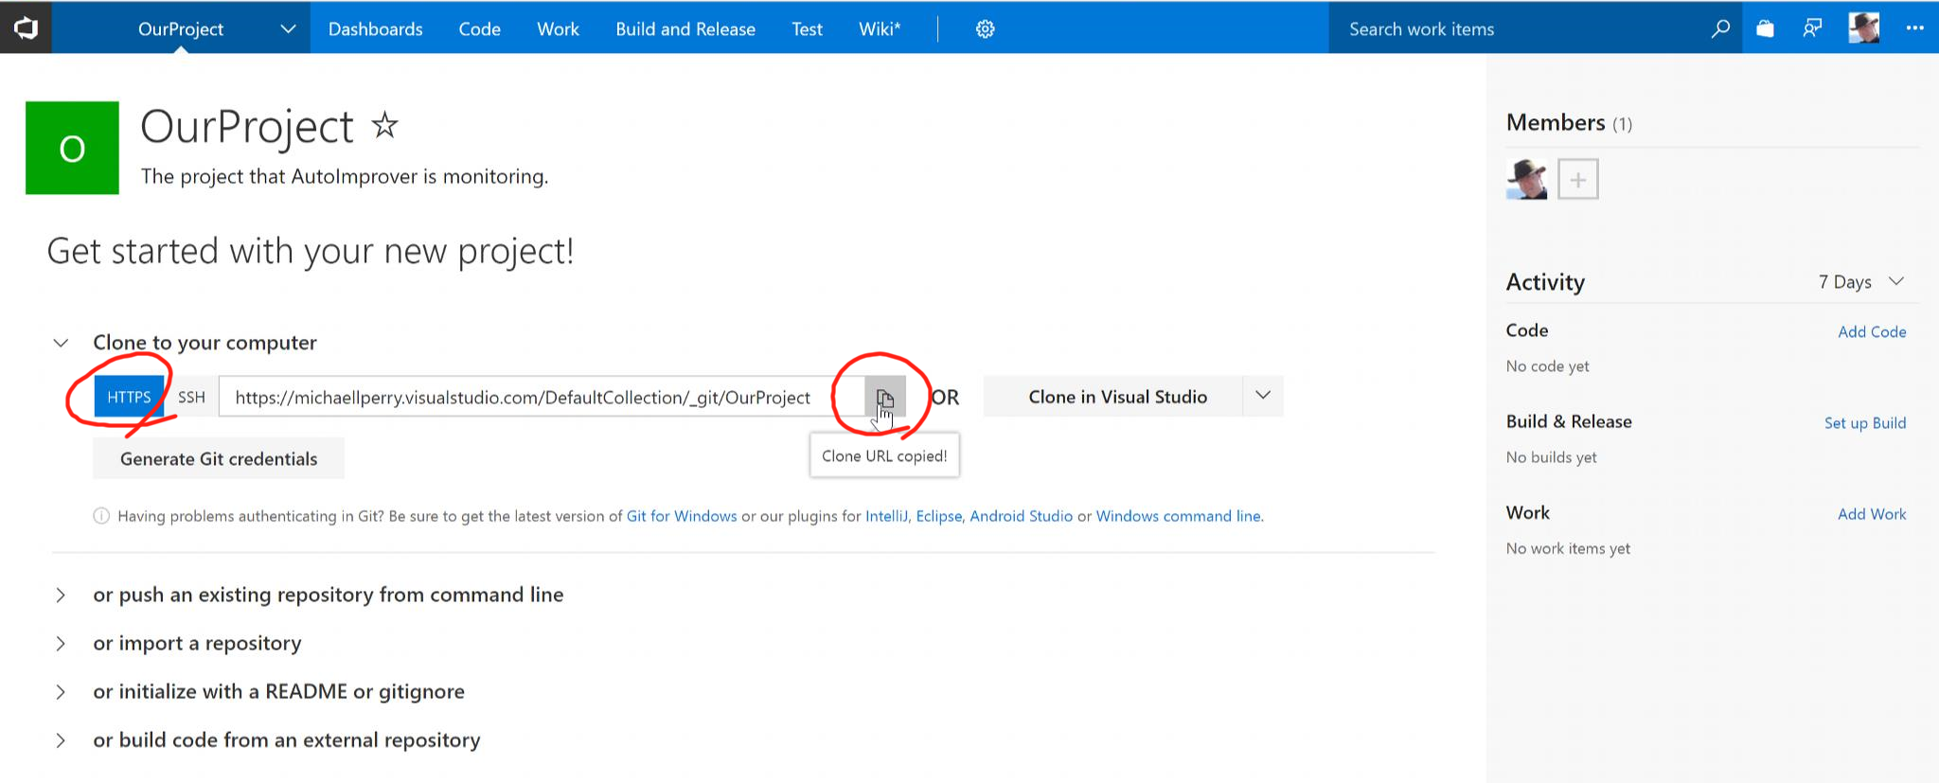

Back in Visual Studio, open Team Explorer, and click “Sync”.  
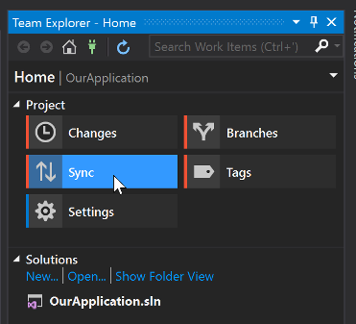

Under “Publish to Remote Repository”, click “Publish Git Repo”. Paste in your URL.  
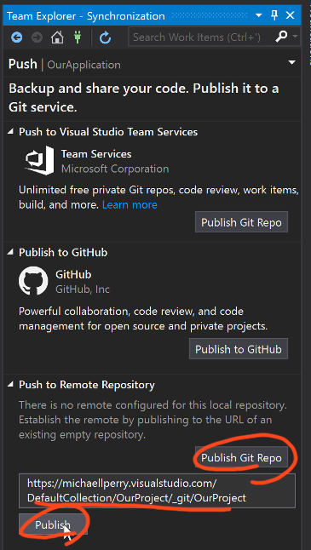

We have source code up on VSTS. Now let’s configure CI.

Go back to VSTS and refresh the page. Click “Set up Build”.  
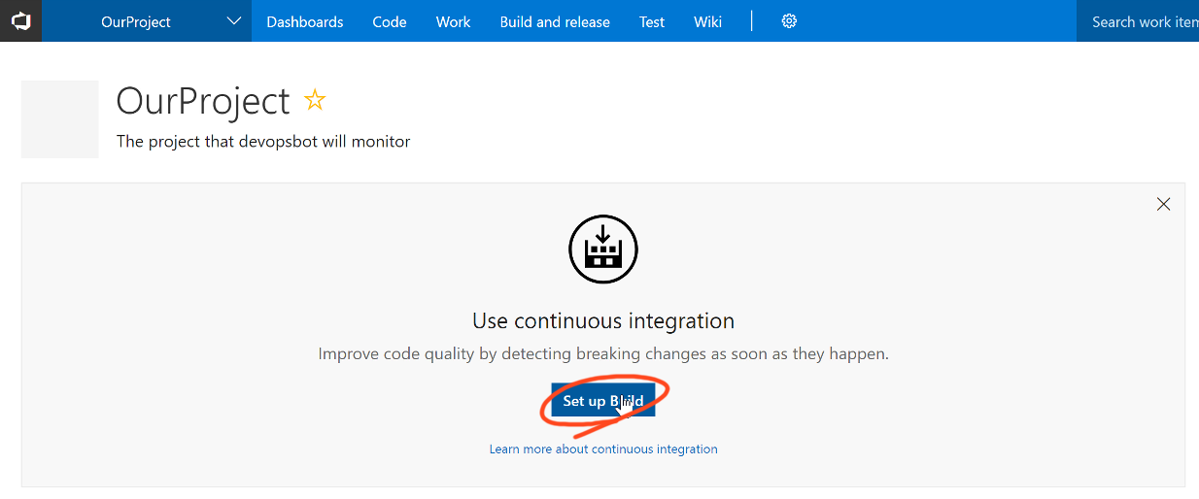

The VSTS Git repository is selected by default. Click “Continue”.  
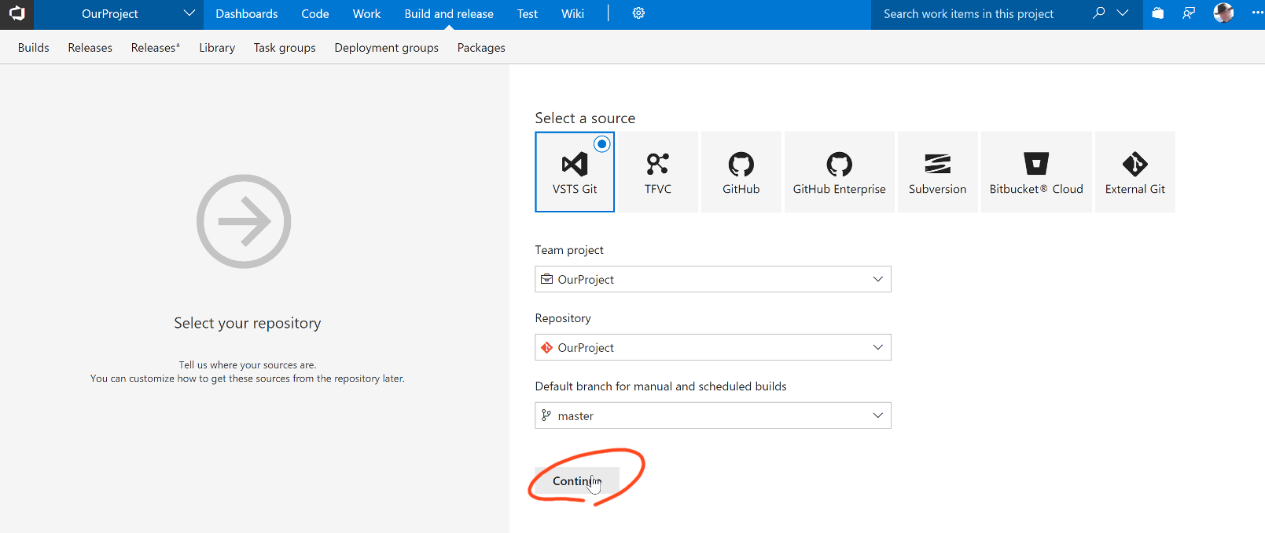

Choose the template “ASP.NET”. The default template is already set up.  
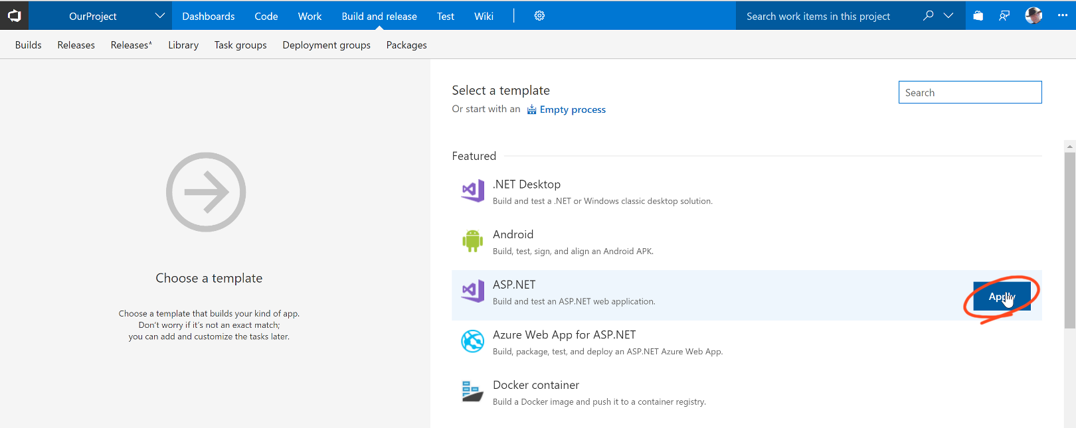

Click “Triggers” and enable continuous integration. Select the “master” branch.  
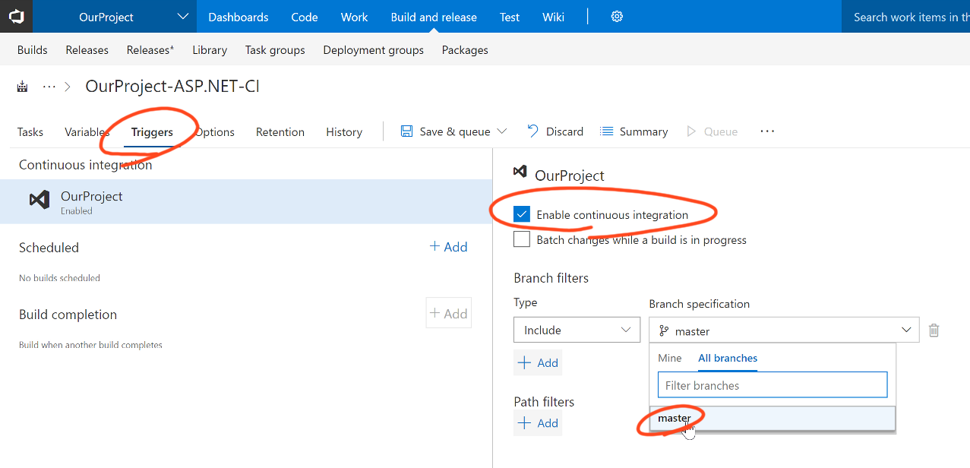

Finally, save your build definition and queue a new build.  
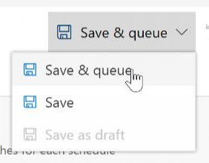

The new build starts. It fetches the source code, pulls in the NuGet repositories, builds the solution, runs the unit tests, and publishes the build artifacts.  
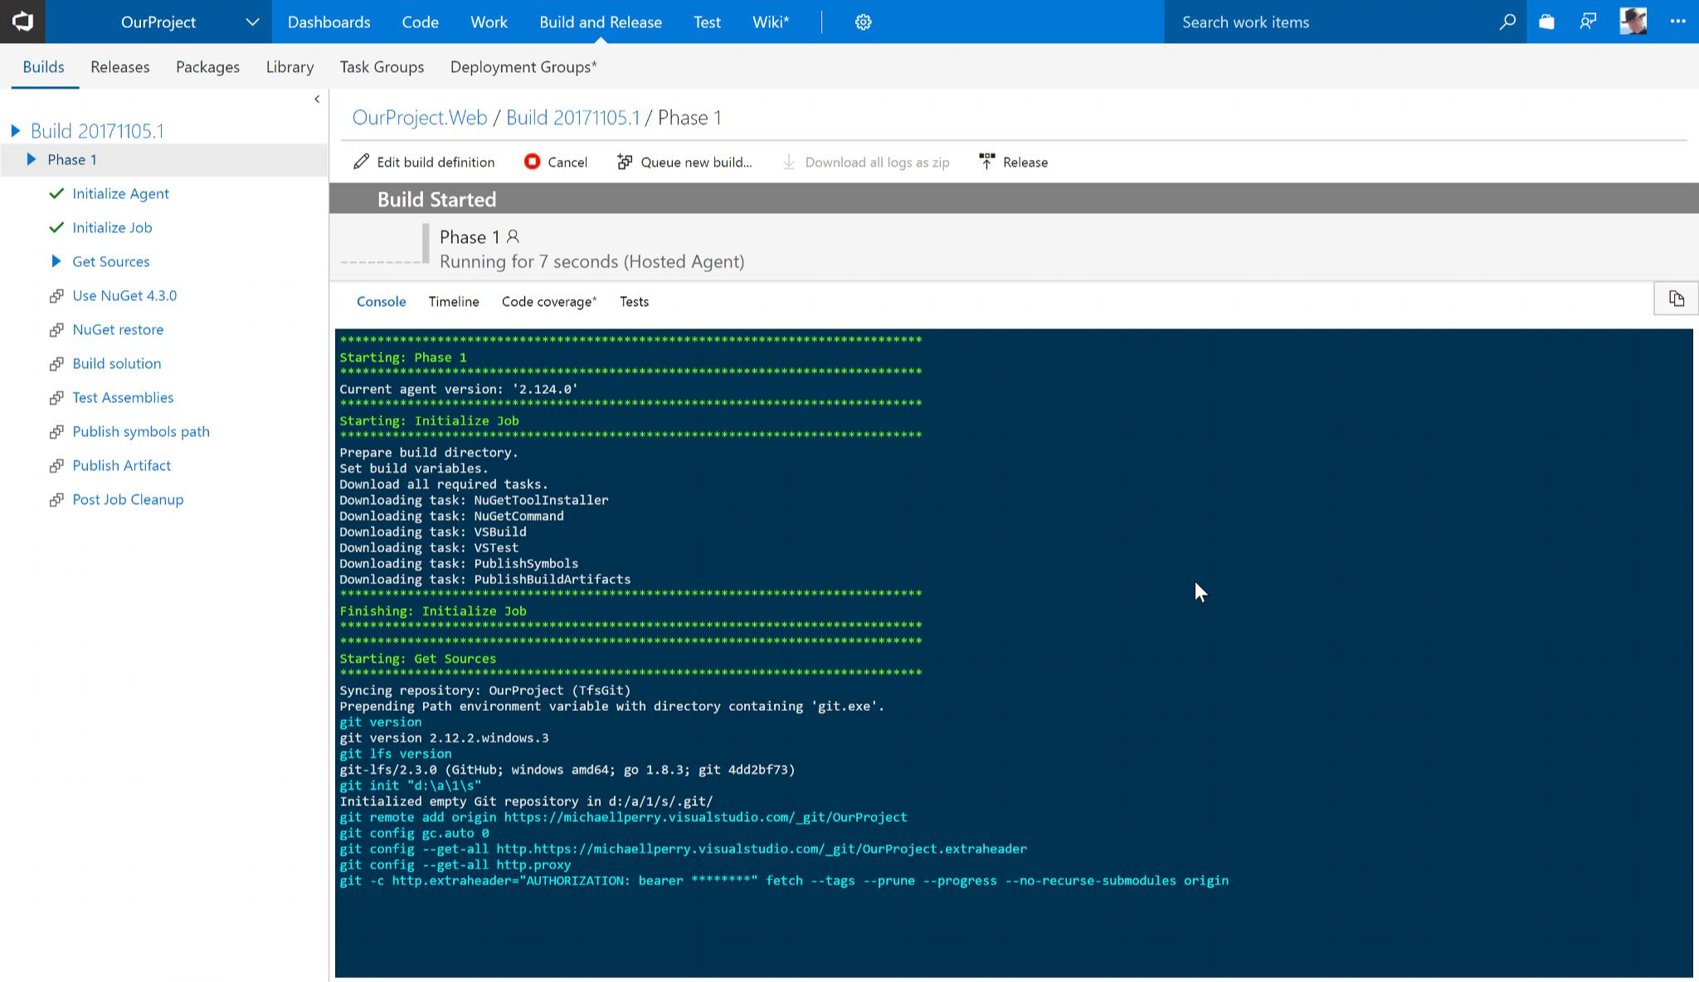

Now that we have CI for our project, let’s give devopsbot the ability to check on builds for us.

Go to your VSTS security page and create a new personal access token. This token will be used to access the project code, not the bot code. This will not necessarily be the same VSTS team, so get in the habit of using a separate personal access token.  
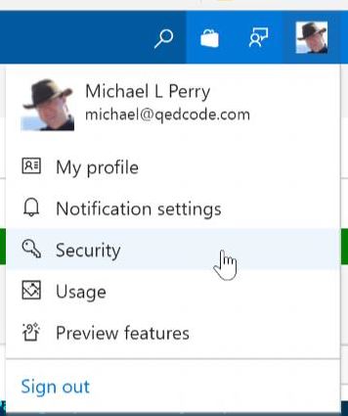

Go to the application settings panel for your bot in Azure and set the application settings for:

* VstsTeamName
* VstsProjectName
* VstsAccessToken
* VstsBuildDefinition

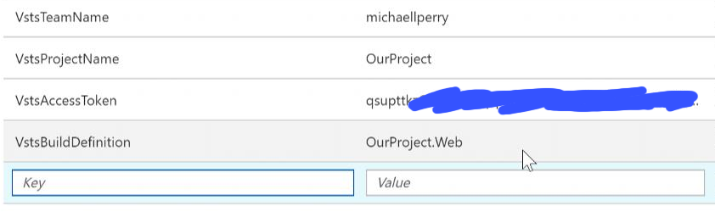

These settings are used in the VstsClient class that you copied from my GitHub project.

When you make these changes, Azure will restart your bot to take on the new application settings. Also make sure that you have committed and pushed your code changes to handle the ListBuilds intent. Now you can go to Slack and ask devopsbot to list the builds for you.  
